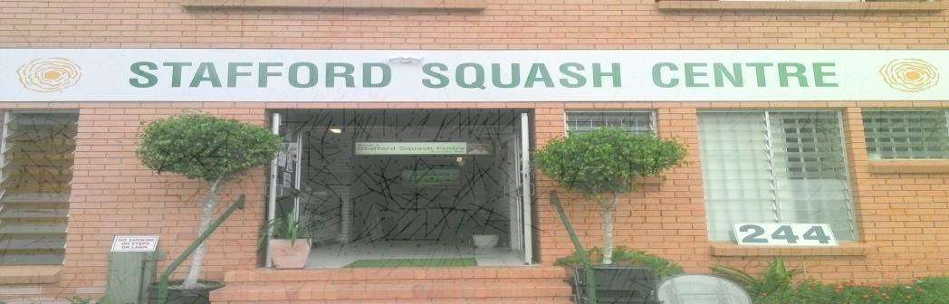
Entry Form
Send to: Stafford Squash Centre, 244 Kitchener Rd, Qld, 4053 or Phone: Kylie on 3359 4578 or Email: centre@staffordsquash.com.au

Full Name___________________________________Male/Female Address________________________________________________ Phone______________________Mobile______________________ Club________________Grade____________Position___________Qld Masters Ranking_____________ I am a member of the QMSA Yes/No (Please Circle) Other Grading info if not a current Masters member: ___________________________________________________________________________________________________________________________________________________________________________________________________________________________________________________________________________________

Stafford Squash Centre
Tournament Conditions
- Players need to be over 30 years of age to compete.
- Players to report to control desk 20 minutes prior to match.
- Players are required to umpire the following match.
- All events will be on a mixed graded individual basis.
- Every effort will be made to give players three matches.
- All events are best of 5.
- Entries may be submitted by email or post.
- Entries close 7th March, 2017
- First match times available on midday, Friday, 10th.

Accommodation
- Chermside Motor Inn – 644 Gympie Road, Chermside, 3359 9255
- Aspley Motor Inn – 1159 Gympie Road, Aspley, 3263 5400
- Chermside Green Motel – 949 Gympie Road, Chermside, 3350 4409
- Aspley Sunset Motel – 9 Darwin Street, Aspley, 3862 7454
- Carseldine Palms Motel – 1631 Gympie Road, Carseldine, 3263 2255



ENTRIES CLOSE TUESDAY 7TH March, 2017
ENTRY FEE MEMBERS $30 NON MEMBERS $35
